Follow Mine Traffic Rules
Be sure to know and follow mine and plant traffic rules and warning signs. These include speed limits, traffic patterns, and which side of the road to drive on.

Honk Before Moving
Best safety practices and MSHA require that all truckers honk their horns when starting from a stop that is not a stop-and-go situation. Horns should also be honked prior to moving if there are nearby hazards, such as blind spots, traffic, or people. This protects miners and truckers who may be unaware that your truck is about to move.

Have a Back-Up Alarm
Trucks hauling aggregates, cement or other materials in California are required by the California Vehicle Code to have a working back-up alarm. Requirements for the type of back-up alarm, or use of a spotter, vary by agency.
Remember!
- Use seat belts!

- Yield the right of way to heavy equipment

- Don’t pull behind a loader or heavy equipment

- Stay alert to workers on foot and pickups
Exit a Mine Carefully
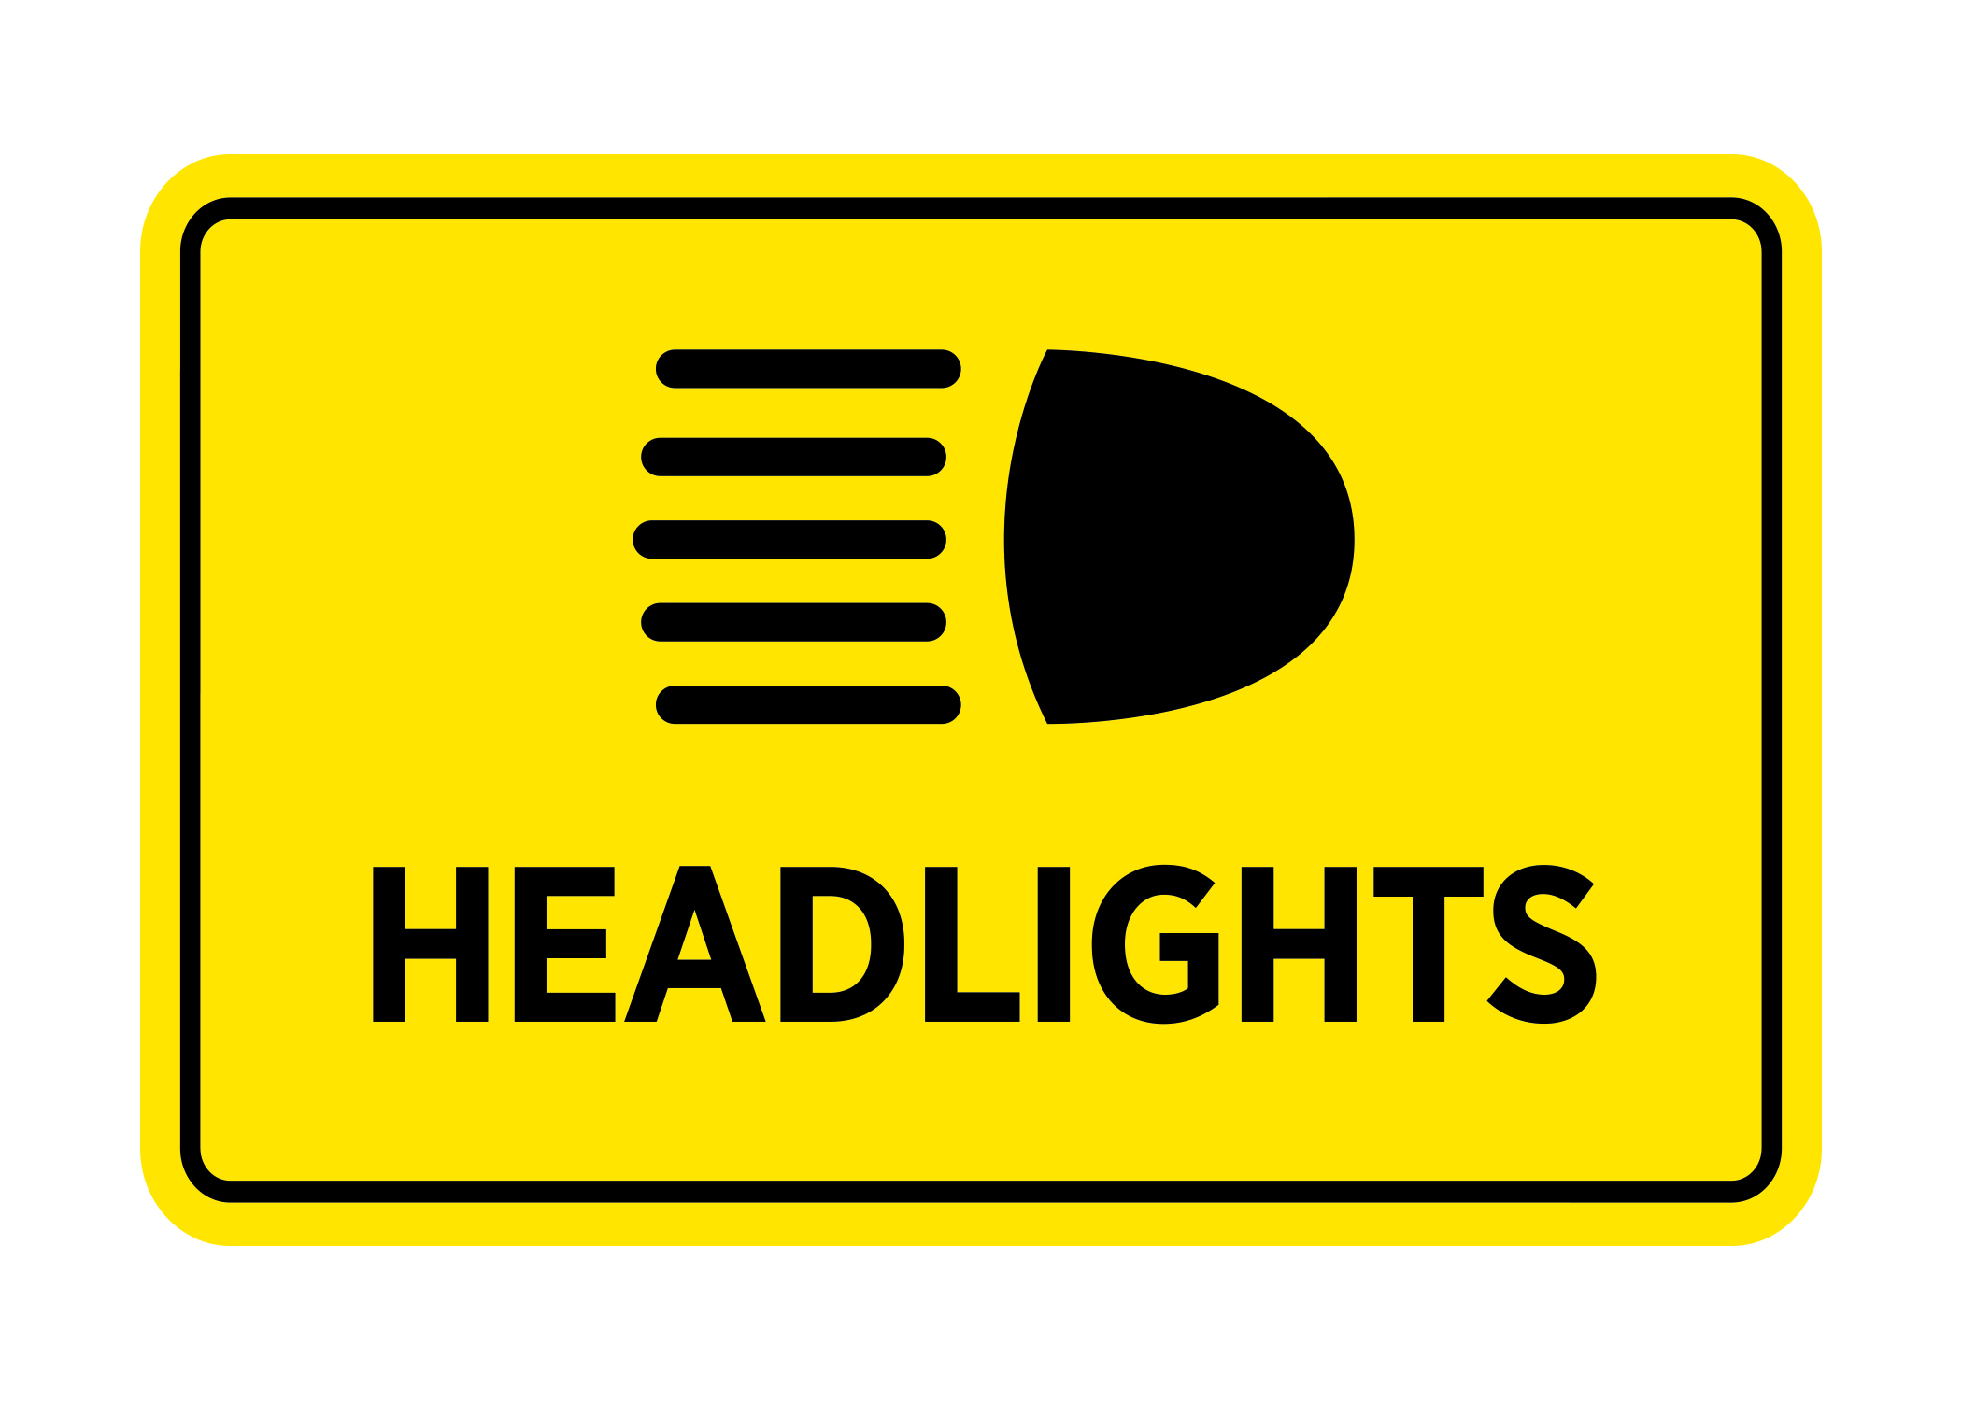
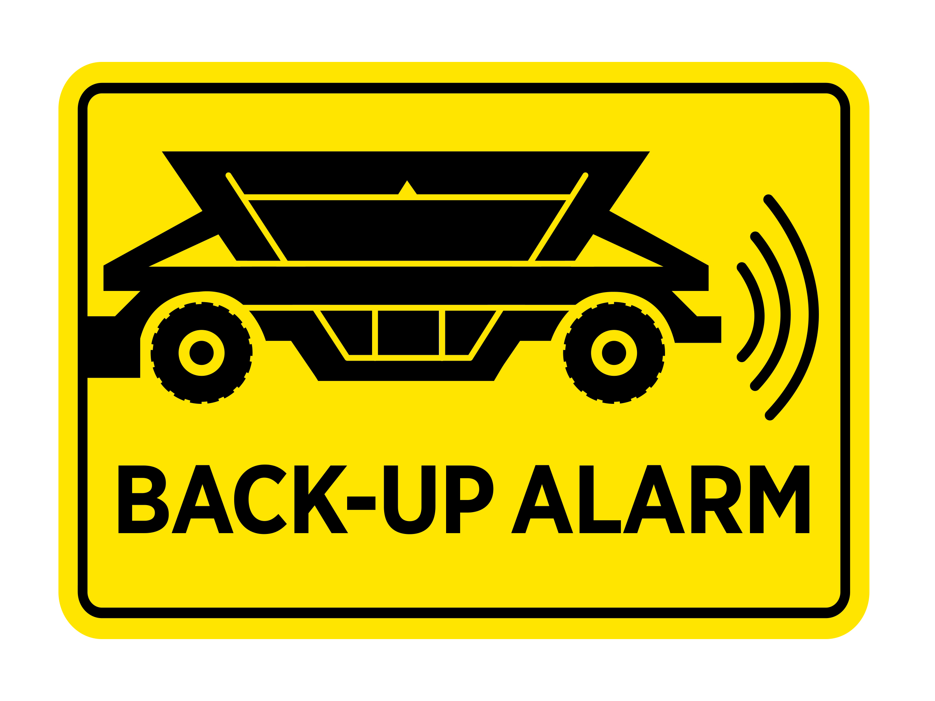
How you exit a mine and drive on the roads near a mine can be important to the home owners, farmers, businesses, and other drivers in the local community. Some mines will require wheel washing to reduce dust and track out from the mine. When exiting onto public roads, be careful to avoid on-coming traffic. Use common road courtesy with other drivers when exiting the mine.

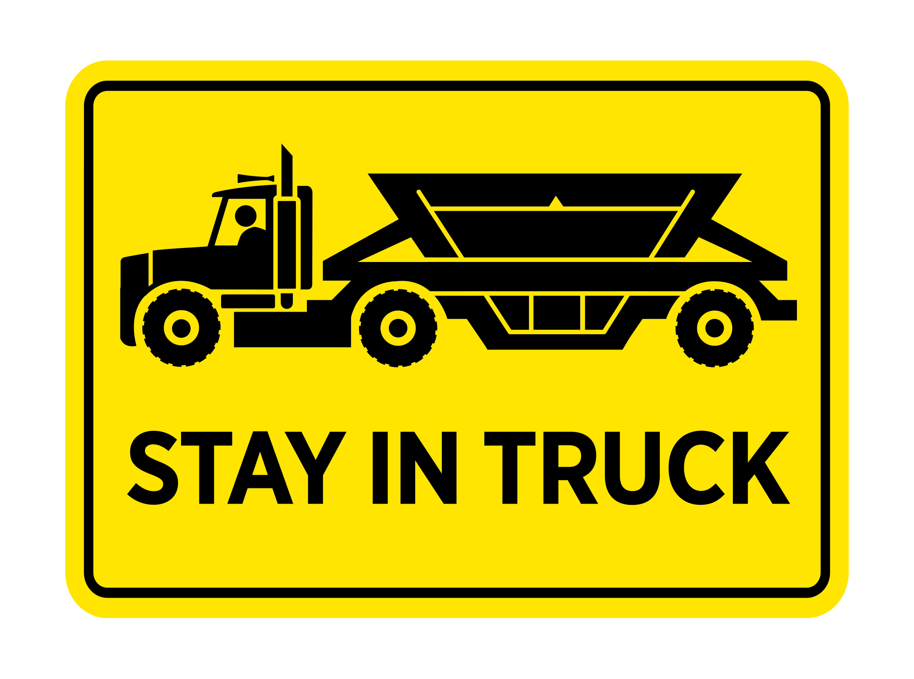
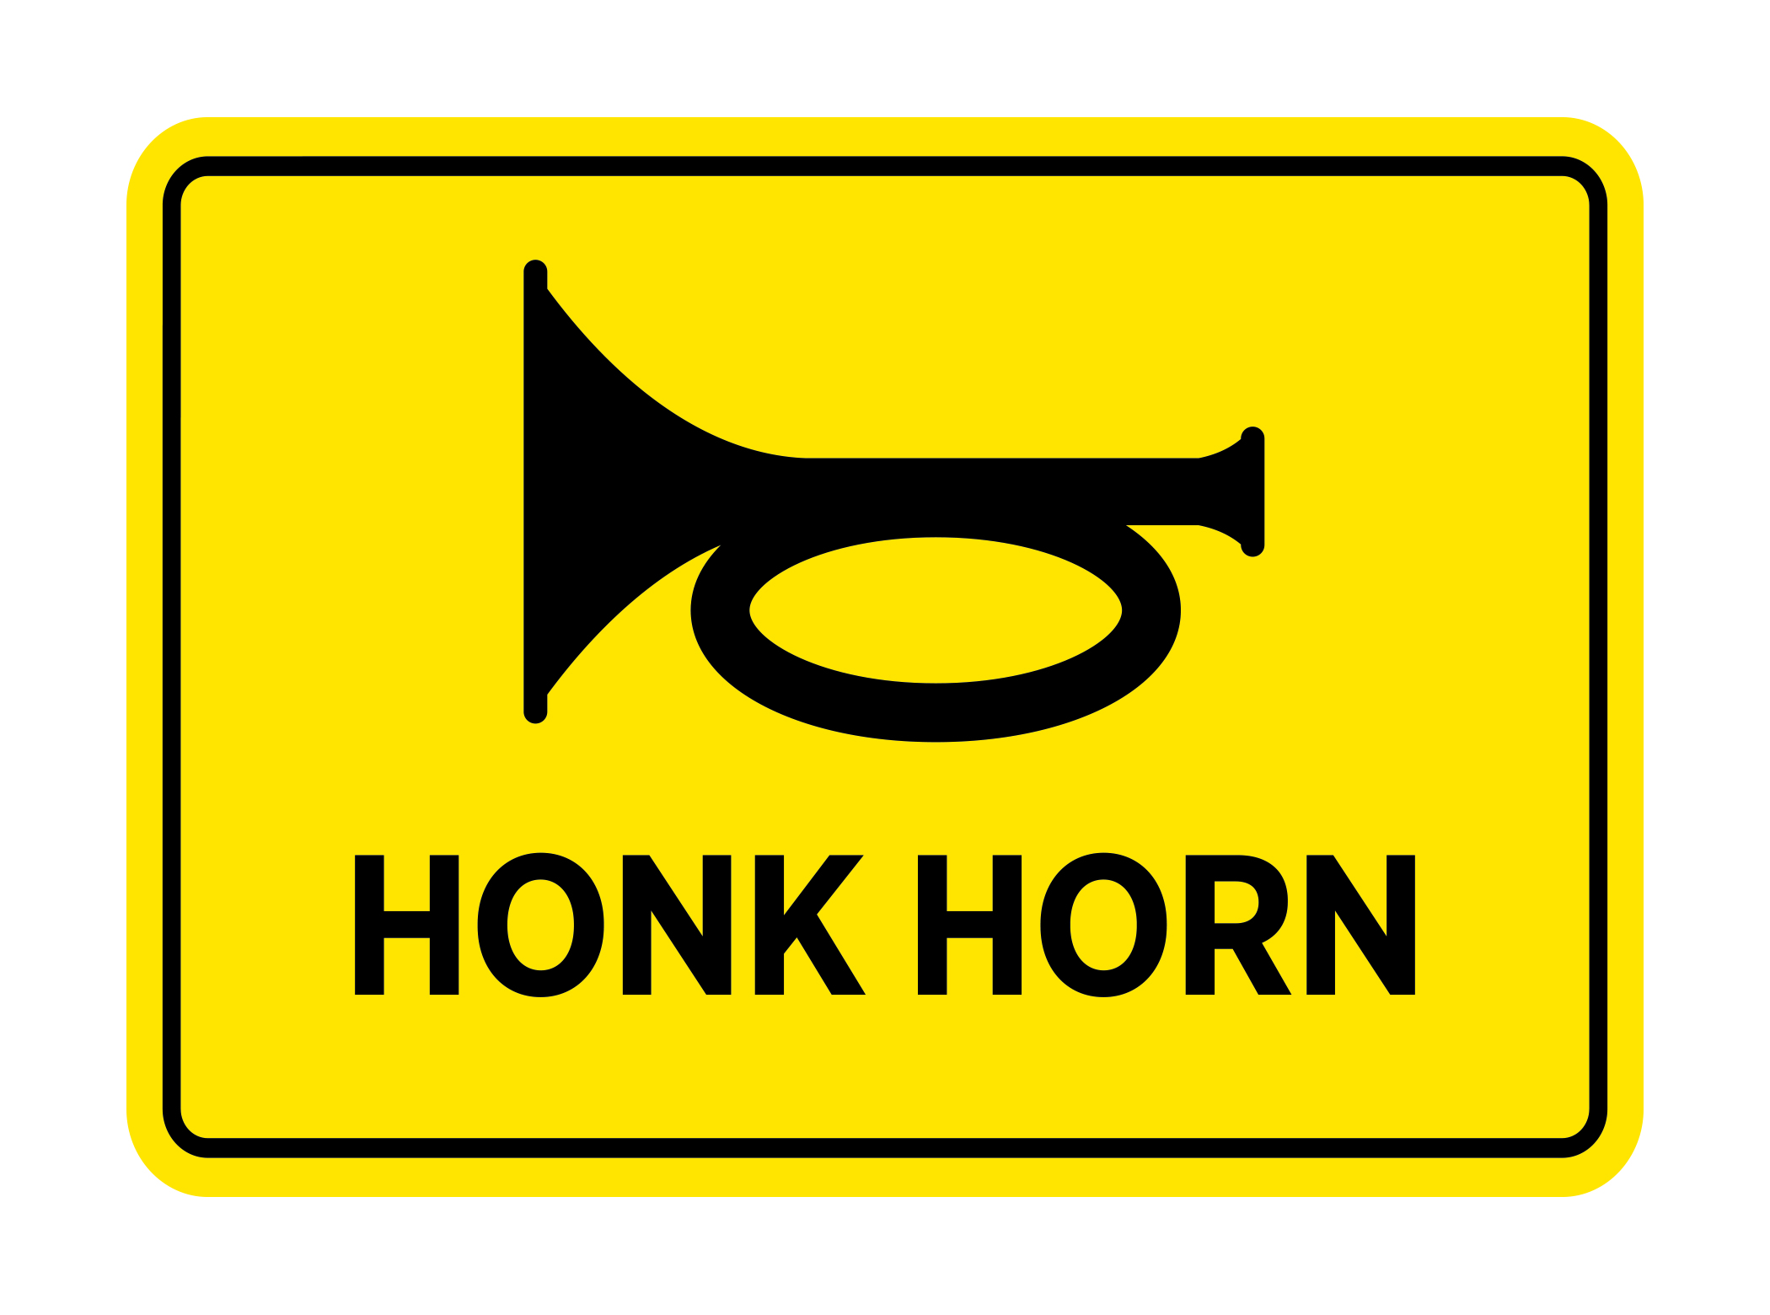
Know Your Routes
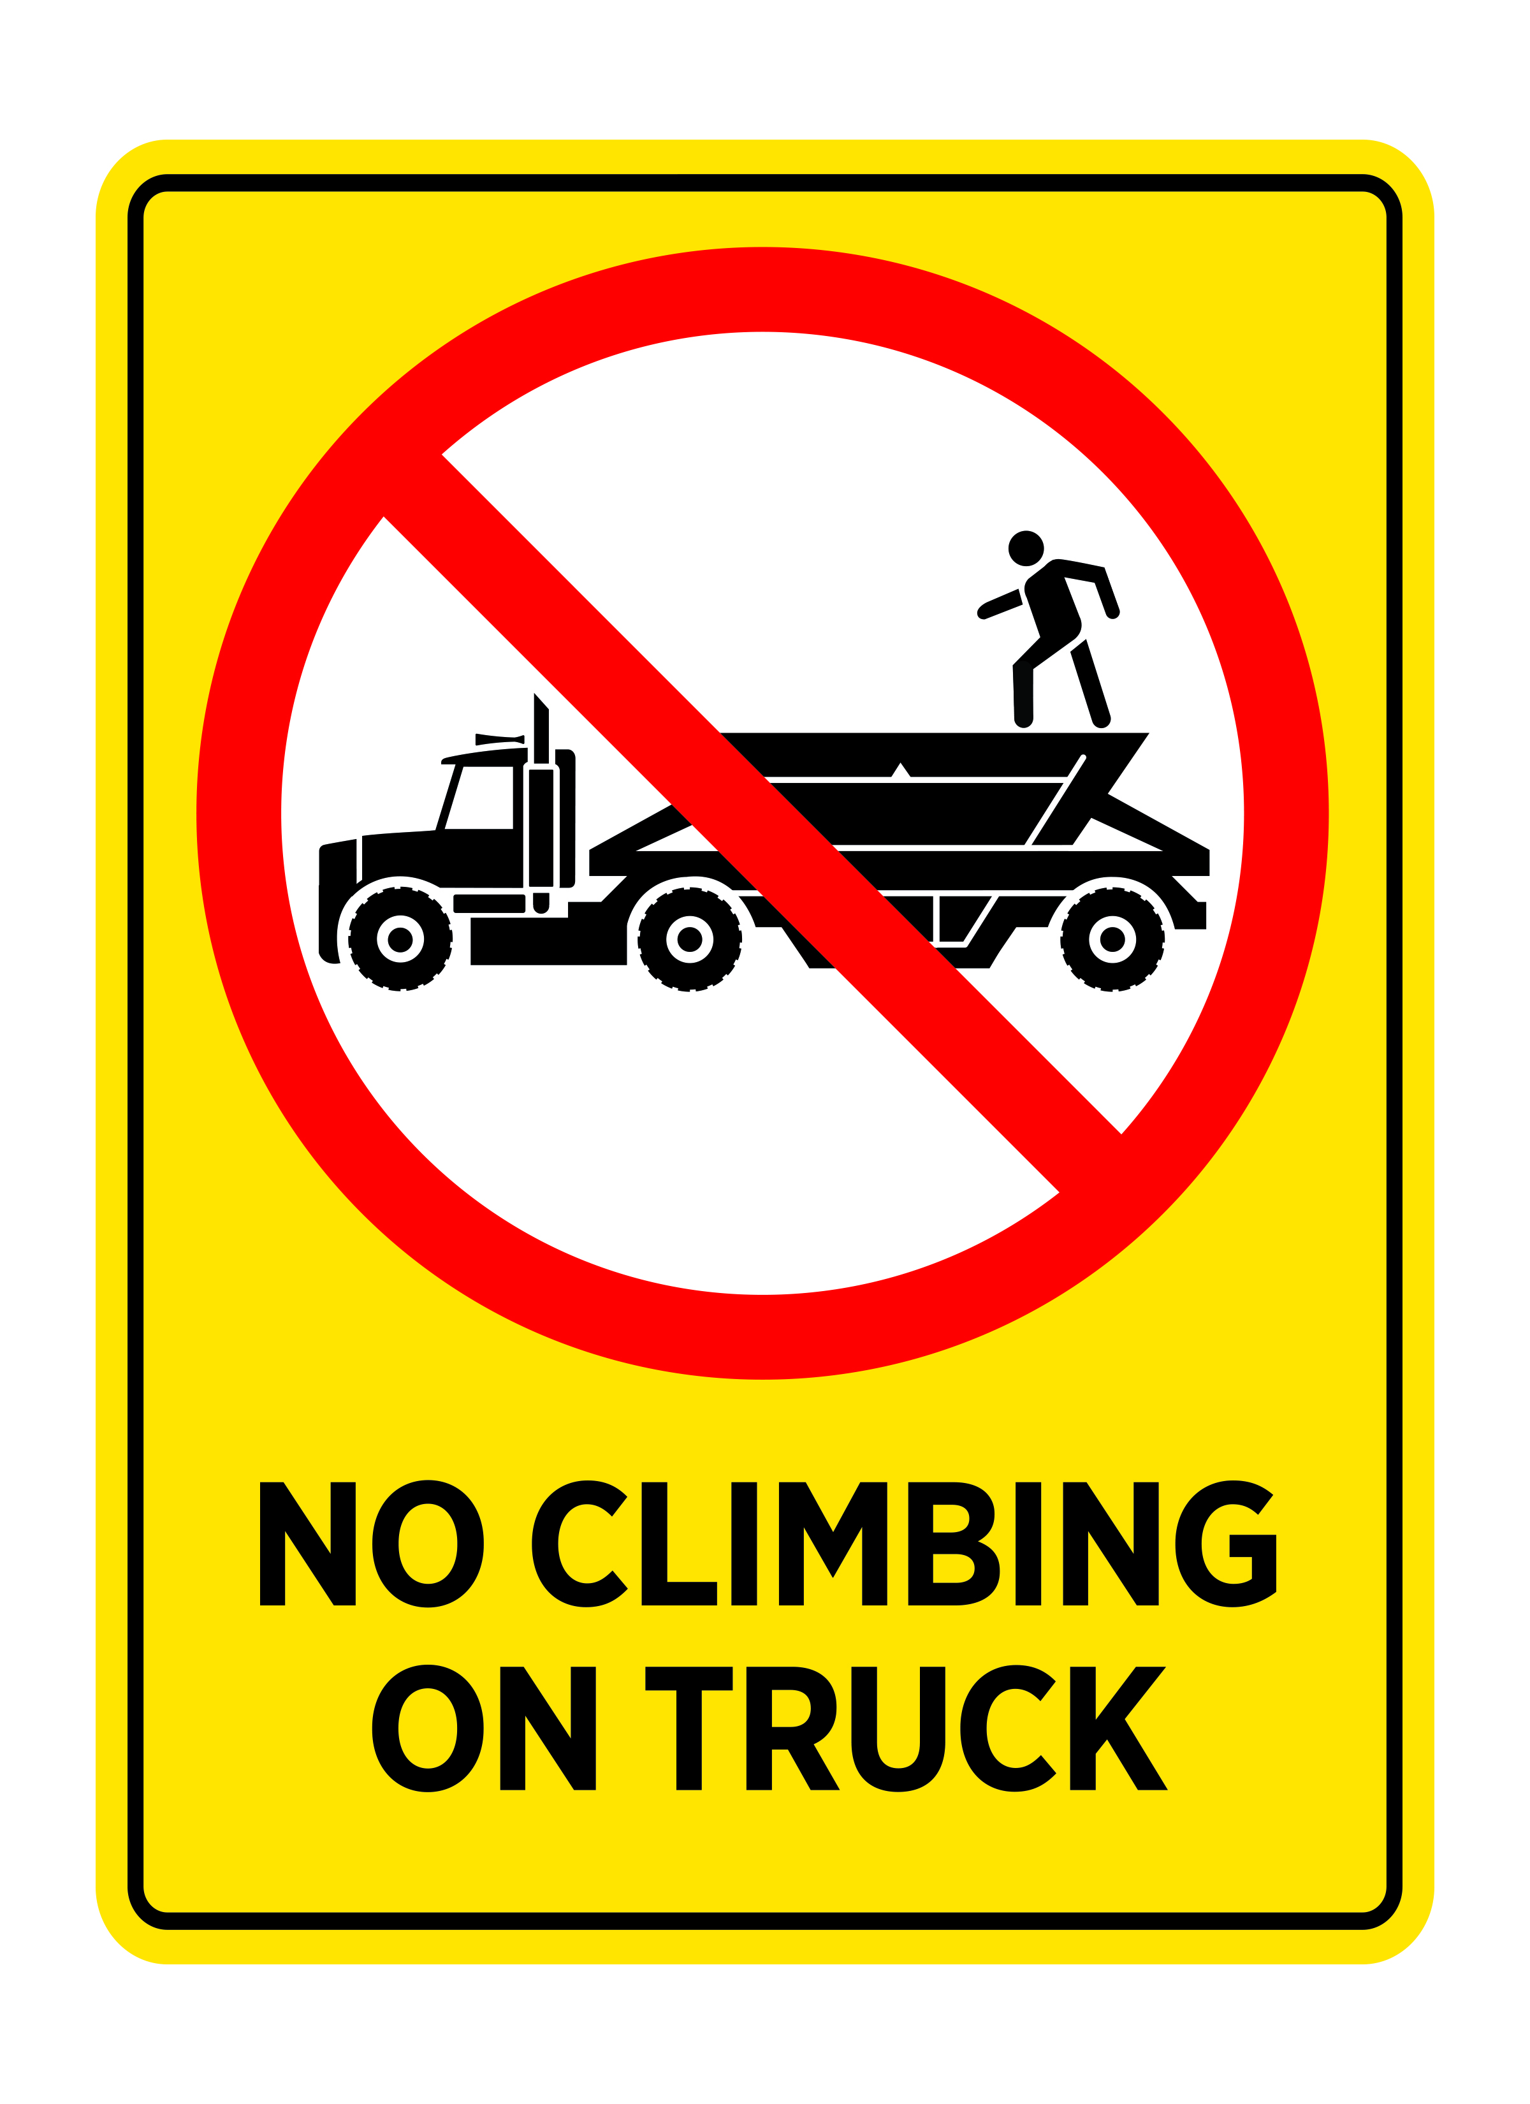
Be sure to know which roads to take to projects sites or batch plants. Some communities will have special speed limits or routes for truck travel. Pre-planning of trips saves time and makes for a safer trip.
Logo
Company Name
Street Address
Address 2
City, ST ZIP Code
Phone (704) 555-0125
Fax (704) 555-0145
Web site address

Truck Safety at Mines

Date of publication

Trucks hauling rock, sand, gravel, limestone, cement and other products from mines and over the highways are vital to business in California. But, these same trucks can also pose safety challenges at mines due to their mobility and the pace of activity.

There are many safety rules at mines, including those imposed by the mine owner as well as federal and state safety agencies. Federal rules are by the Mine Safety & Health Administration (MSHA). State rules are by CalOSHA. The California Highway Patrol (CHP) has authority over vehicles.

Get Mine Site Training
MSHA requires that truckers travelling onto a mine get training on the specific hazards of that mine. To learn how to get this training, contact the scale house or company office. This training generally includes an overview of mine safety and specific hazards that truckers should be aware of.

Penalties
Truckers that don’t follow the safety rules can be subject to penalties. Mines can prohibit a trucker from returning. CalOSHA and CHP can issue fines for violations. MSHA can issue citations to the mine operator or trucking company for violations.
More importantly, serious injuries or death can result when safety rules are not followed on a mine site.

What Are The Hazards?
- Heavy equipment and vehicle traffic, including loaders, scrapers, excavators, haul trucks, water trucks, and pickup trucks.
- Miners and others working at ground level, often near heavy traffic areas.
- Obstructed Visibility. Mines have large vehicles, equipment, and stockpiles that obstruct views in the plant or on roads. Dust and night operations can also reduce visibility.
- Elevated, steep, and narrow roadways
- Falling rock from mine walls, slope failures, or unstable stockpiles
- Overhead wiring and other electrical
- Moving parts on plants and conveyors
- Tripping and falling hazards for drivers from debris, rocks, uneven surfaces, and equipment.
- Water hazards, such as retention ponds and other water bodies.
- Explosives and blasting activity at the mine.
Here are a few general rules and procedures to protect yourself and other workers at a mine.
Stay In Your Trucks
If possible, stay in your truck! Every time a driver steps out of their truck, the hazards for a driver increase. If you do get out of your truck, wear hard hats, safety glasses, vests, and other protective equipment.

Headlights ON
A good safety practice is to drive with your headlights on while driving in a mine site.

Do Not Climb on Trucks!
Every time a trucker climbs on a truck there is a possibility for a fall. Even falling 6 feet can kill you. Most mines prohibit climbing on trucks or trailers. Here are some options to consider:
- Use a tarping system that can be operated from the cab or ground.
- Request assistance from a loader operator to adjust or level the load.
- Utilize a loading structure, if available, to rake the load. If necessary, remember to use safety harnesses to avoid a fall.
- Only tarp or trim loads in designated areas.

